
PROGRAM TO SEARCH AN ELEMENT IN ARRAY
USING BINARY SEARCH
AIM:
To write array program using binary concepts
ALGORITHM:
STEP 1: start
STEP 2: declare no of elements (n) elements to search (key)
STEP 3: initialization array with n(arr[n])
STEP 4: i=0
STEP 5: get arr[i]
STEP 6: i++
STEP 7: if i<n goto step 5,else continue
STEP 8: read element to search(key)
STEP 9: result = binary search(arr,n,key)
STEP 10: if (result!=1)
STEP 11: print element found at position(result)else
print element not found
STEP 12: stop
ALGORITHM FOR BINARY SEARCH:
STEP 1: int low=o, high=n-1
STEP 2: if low(<=high)
STEP 3: mid=(low+high)/2
STEP 4: if (arr[mid]==key)
return mid
STEP 5: else if (arr[mid]<key)
low=mid+1
else


high+mid-1
STEP 6: goto step 2
STEP 7: return-1
FLOWCHART :


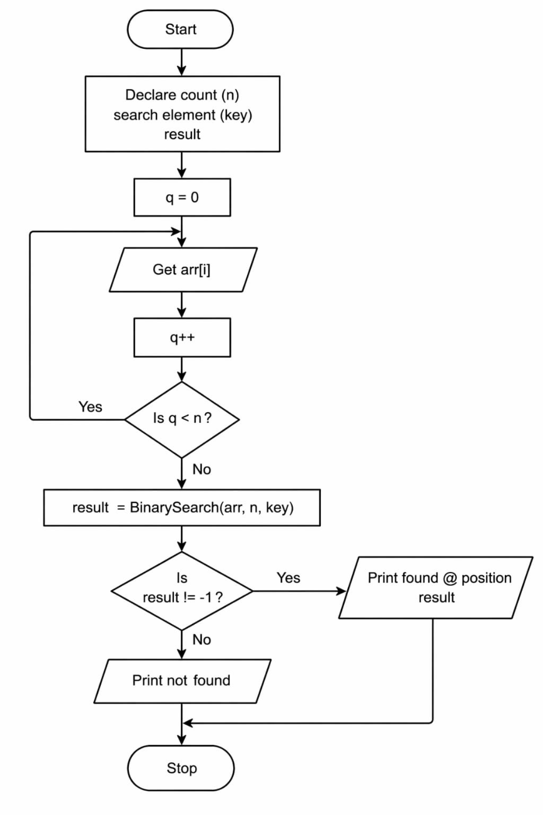


ALGORITHM FOR BINARY SEARCH :


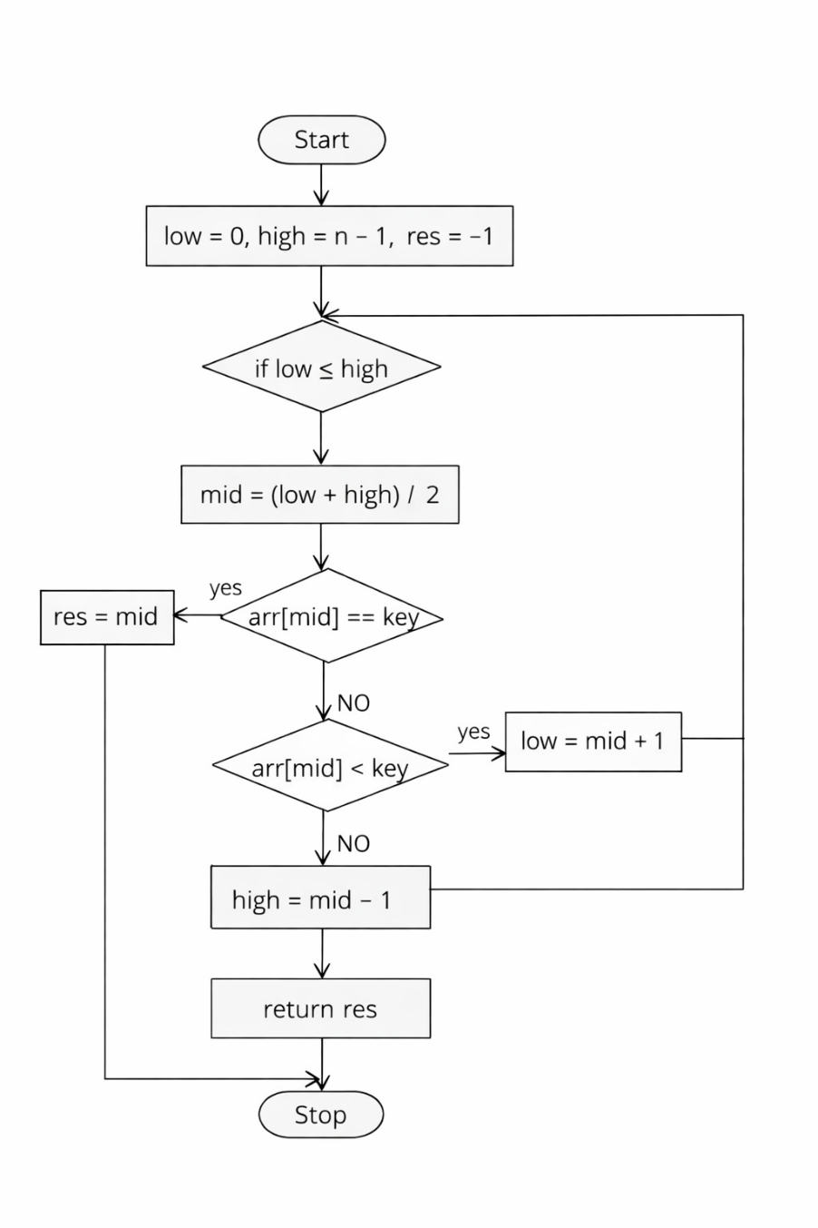


CODING :
#include<stdio.h>
int binarysearch(int arr[],int n, int key)
{
int low=0,high=n-1,mid;
while(low<=high)
{
mid=(low+high)/2;
if (arr[mid]==key)
return mid;
//element found
else if(arr[mid]<key)
low=mid+1;
//search right half
else
high=mid-1;
//search left half
}
return 1;
//element not found
}
int main()
{
int n,key,result;
printf("enter number of element:");
scanf("%d",&n);
int arr[n];
printf("enter %d sorted element:\n",n);
int i;
for(i=0;i<n;i++){
scanf("%d",&arr[i]);


}
printf("enter element to search:");
scanf("%d",&key);
result = binarysearch(arr, n, key);
if(result!=-1)
printf("element found at index %d \n",result);
else
printf("element not found \n");
return 0;
}
OUTPUT :
enter no of element : 5
enter 5 sorted element
11
12
13
14
15
enter element to search : 14
enter found at index : 3


RESULT :
Thus the program compiled and executed
successfully with verified output

